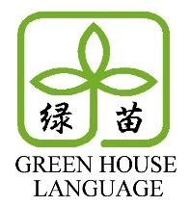
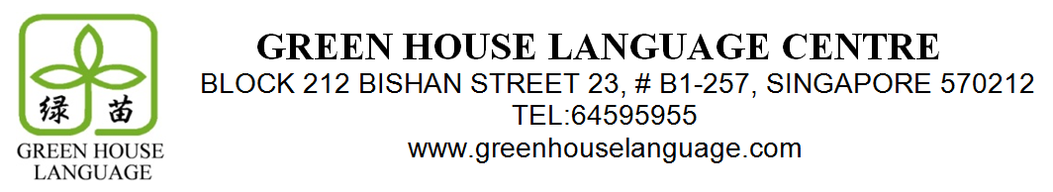

Dear Parents,
As the year draws to a close and with the O-Levels looming next year, we will be opening special preparatory Holiday Chinese Enrichment Classes for next year’s exams. These classes will specifically target the most challenging aspects of the exams, focusing on essays, comprehension, and oral skills. They will highlight key techniques and methods to best grapple with the difficulties the O-Levels pose.
The Holiday Class package will be a set of five 2-hour lessons, as set out below. Should your child be unable to attend any of the lessons, we will endeavour to offer a replacement. As places are limited, we are opening registration first to existing students, at a preferential rate of $240 for the whole package. Please complete this form and submit it, with payment by cash or cheque (payable to ‘Green House Language Centre’), by Oct 22 to register.
Lesson Number | Date and Time
1 | 27th November, Monday, 11:00am – 1:00pm
2 | 28th November, Tuesday, 11:00am – 1:00pm
3 | 29th November, Wednesday, 11:00am – 1:00pm
4 | 30th November ,Thursday, 11:00am – 1:00pm
5 | 1st December, Friday , 11:00am – 1:00pm

Name of Student: ______________________ (Chinese) _________________________ (English)
Mode of Payment: Cash/Cheque* Cheque No.: ______________ Bank: __________

Dear Parents,
As the year draws to a close and with the O-Levels looming next year, we will be opening special preparatory Holiday Chinese Enrichment Classes for next year’s exams. These classes will specifically target the most challenging aspects of the exams, focusing on essays, comprehension, and oral skills. They will highlight key techniques and methods to best grapple with the difficulties the O-Levels pose.
The Holiday Class package will be a set of five 2-hour lessons, as set out below. Should your child be unable to attend any of the lessons, we will endeavour to offer a replacement. As places are limited, we are opening registration first to existing students, at a preferential rate of $240 for the whole package. Please complete this form and submit it, with payment by cash or cheque (payable to ‘Green House Language Centre’), by Oct 22 to register.
Lesson Number | Date and Time
1 | 27th November, Monday, 11:00am – 1:00pm
2 | 28th November, Tuesday, 11:00am – 1:00pm
3 | 29th November, Wednesday, 11:00am – 1:00pm
4 | 30th November ,Thursday, 11:00am – 1:00pm
5 | 1st December, Friday , 11:00am – 1:00pm

Name of Student: ______________________ (Chinese) _________________________ (English)
Mode of Payment: Cash/Cheque* Cheque No.: ______________ Bank: __________

Dear Parents,
As the year draws to a close and with the O-Levels looming next year, we will be opening special preparatory Holiday Chinese Enrichment Classes for next year’s exams. These classes will specifically target the most challenging aspects of the exams, focusing on essays, comprehension, and oral skills. They will highlight key techniques and methods to best grapple with the difficulties the O-Levels pose.
The Holiday Class package will be a set of five 2-hour lessons, as set out below. Should your child be unable to attend any of the lessons, we will endeavour to offer a replacement. As places are limited, we are opening registration first to existing students, at a preferential rate of $240 for the whole package. Please complete this form and submit it, with payment by cash or cheque (payable to ‘Green House Language Centre’), by Oct 22 to register.
Lesson Number | Date and Time
1 | 27th November, Monday, 11:00am – 1:00pm
2 | 28th November, Tuesday, 11:00am – 1:00pm
3 | 29th November, Wednesday, 11:00am – 1:00pm
4 | 30th November ,Thursday, 11:00am – 1:00pm
5 | 1st December, Friday , 11:00am – 1:00pm

Name of Student: ______________________ (Chinese) _________________________ (English)
Mode of Payment: Cash/Cheque* Cheque No.: ______________ Bank: __________

Dear Parents,
As the year draws to a close and with the PSLE looming next year, we will be opening special preparatory Holiday Chinese and English Enrichment Classes for next year’s exams. These classes will specifically target the most challenging aspects of the exams, focusing on essays, comprehension, and oral skills. They will highlight key techniques and methods to best grapple with the difficulties the PSLE poses.
Both the English and Chinese holiday classes will consist of five 2-hour lessons, as set out below. Should your child be unable to attend any of the lessons, we will endeavour to offer a replacement. As places are limited, we are opening registration first to existing students, at a preferential rate of $220 for either Chinese or English classes, and $400 for both. Please complete this form and submit it, with payment by cash or cheque (payable to ‘Green House Language Centre’), by Nov 5 to register.
Chinese | Date and Time
Lesson 1 | 27th November, Monday, 9:30am – 11:30am
Lesson 2 | 28th November, Tuesday, 9:30am – 11:30am
Lesson 3 | 29th November, Wednesday, 9:30am – 11:30am
Lesson 4 | 30th November ,Thursday, 9:30am – 11:30am
Lesson 5 | 1st December, Friday , 9:30am – 11:30am
English | Date and Time
Lesson 1 | 27th November, Monday, 11:30am – 1:30pm
Lesson 2 | 28th November, Tuesday, 11:30am – 1:30pm
Lesson 3 | 29th November, Wednesday 11:30am – 1:30pm
Lesson 4 | 30th November ,Thursday, 11:30am – 1:30pm
Lesson 5 | 1st December, Friday, 11:30am – 1:30pm

Name of Student: ______________________ (Chinese) _________________________ (English)
Courses: Both/English Only/Chinese Only* Cheque No./Cash: ______________ Bank: __________

Green House Language Centre
BLOCK 212 BISHAN STREET 23, #B1-257, Singapore 570212
Tel: 6459 5955
www.greenhouselanguage.com

